CS 40A Café

FinAL REPORT FOR THE QUARTER

TEAM 03

Mehdi Fourzabadi

Henry Fan

Karthik Krishnamurthy

Daniel Golub

Spring 2019

**Topline Summary**

**Main Contributions**

1. Conceptualized a practical game based on real-world experience working in hospitality industry
2. Designed the game as finite state machine
3. Implemented portions of the program. New learnings beyond CS 1B
   1. JavaFX
   2. Threads in Java
   3. SceneBuilder and FXML interface
4. Identified elements that we can work on beyond the class to complete

**Challenges**

1. Testing
2. GitHub
3. **Conceptualized a practical game**

**Objective:**

To achieve maximum score within the time limit of the game.

**Score: 10 points for each customer served correctly**

**Time Limit:** 5 mins

**Current Rules:**

1. 10 points for each customer served correctly.
   1. Menu being offered within 15 secs of being seated
   2. Water being served within 15 secs of being offered Menu
   3. Food being served within 15 secs of being served Water
2. If last event is more than 15 secs old then customer departs. Last event can be one of:
   1. being seated or
   2. being offered menu, or
   3. being served water or
   4. being served food
3. A new customer instance is generated every 10 secs for the duration of the game which is initially set to 5 mins or 300 secs
4. If no seat is available then the customer leaves without entering restaurant (no queue)
5. Scoring is done at two events during the game
   1. When a customer leaves the restaurant – points accrued by the customer are calculated
   2. When the end the game ends – points for the people still sitting at the table are calculated
   3. Total score is the sum of the two event scores.
6. **Designed game as finite state machine**

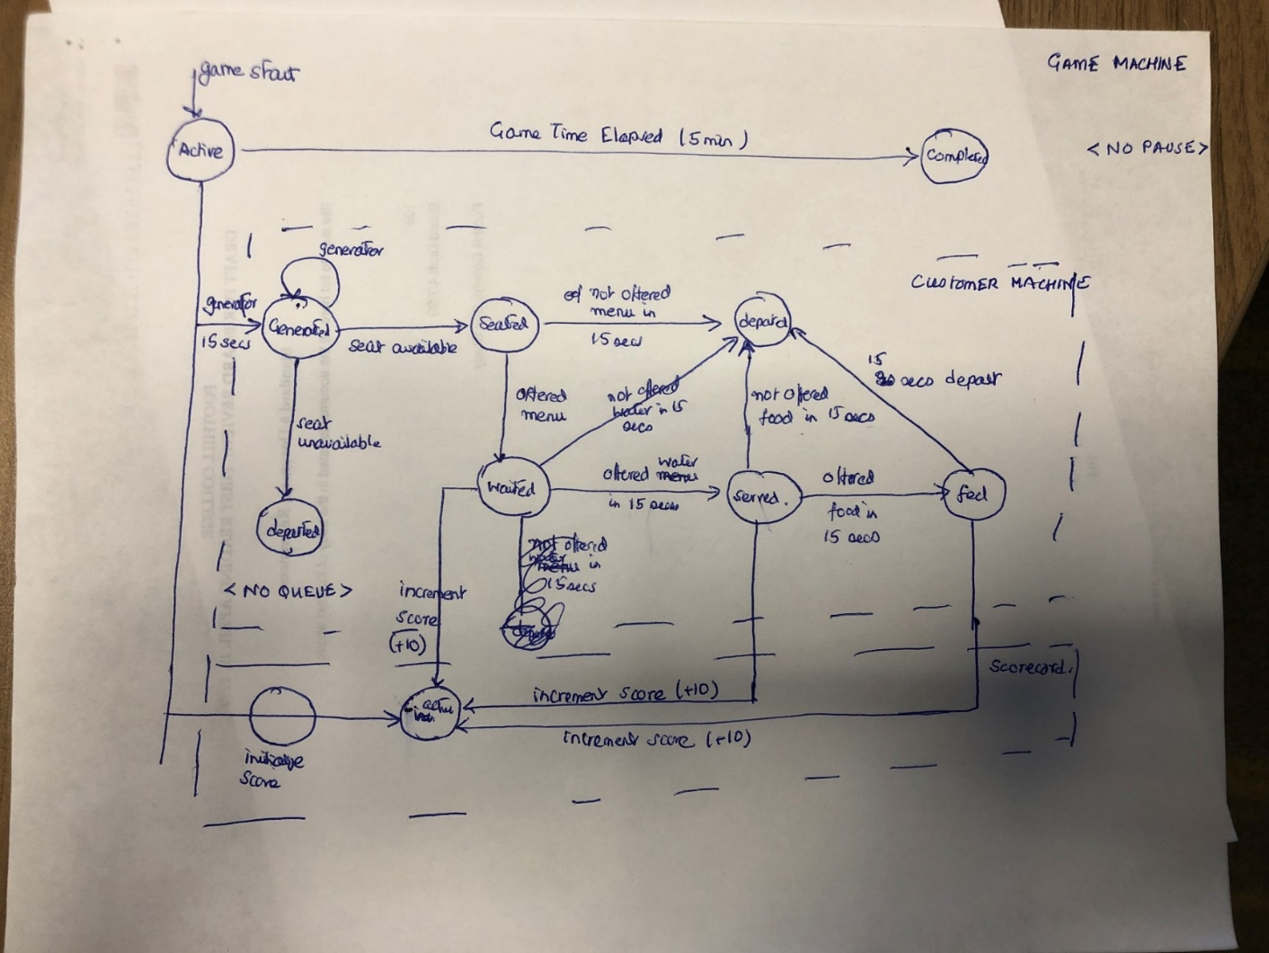

1. **Identified Next Steps**
2. Customer Queue
   1. Extension: if no seat is available then the customer is placed in a queue
   2. Advanced: Customers can elect to leave the queue
   3. Super Advanced: Reservations or Priority Queues (points deducted for missing priority customers)
3. Customer Profile
   1. Extension: Three types of customers: Relaxed, Normal, Harried
   2. Advanced: Penalty points for missing high priority customers
   3. Super Advanced; Resource Mapping – so moving more resources to “high roller” tables, understaffed days
4. Implement Water, Food and Remove Customer Methods